STATE OF ILLINOIS Firm No.: 59049
COUNTY OF COOK

IN THE CIRCUIT COURT OF COOK COUNTY, ILLINOIS
COUNTY DEPARTMENT - CHANCERY DIVISION

BAYVIEW LOAN SERVICING, LLC
Plaintiff, | Case No. 18 CH 03357  Cal No.: 63
vs.
vs. | Property Address:  2220 Eastview Dr.
JOSEPH G. MCGING; KIMBERLY A. MCGING; BANK OF AMERICA, N.A., SUCCESSOR BY MERGER TO LASALLE BANK, N.A.; UNKNOWN TENANTS; UNKNOWN OWNERS AND NON-RECORD CLAIMANTS | Des Plaines, IL 60018
Defendant(s).

ANSWER TO COMPLAINT TO FORECLOSE MORTGAGE

NOW COMES Defendant, BANK OF AMERICA, N.A. SUCCESSOR BY MERGER TO LASALLE BANK, N.A. by and through its attorneys, MARINOSCI LAW GROUP, P.C. and in answer to the Complaint in the above-captioned case states as follows:
1. Defendant admits the allegations in paragraph 1.
2. Defendant neither admits nor denies paragraph 2, since it has insufficient knowledge to form a belief as to the truth thereof, but demands strict proof of same.
3. Defendant neither admits nor denies paragraph 3, subparagraphs (A), (B), (C), (D), (E), (F), (G), (H), (I), (J), (K) since it has insufficient knowledge to form a belief as to the truth thereof, but demands strict proof of same.
4. Defendant admits the allegations in paragraph 3, subparagraph (L), furthermore, attached as Exhibit A to its Answer is a true and correct copy of its recorded Mortgage. Said mortgage is a valid second lien on the subject premises, subordinate only to the first lien held by BAYVIEW LOAN SERVICING, LLC.
5. Defendant neither admits nor denies paragraph 3 subparagraphs (M), (N), (O), (P), (Q), (R), (S), (T) since it has insufficient knowledge to form a belief as to the truth thereof, but demands strict proof of same.
WHEREFORE, Defendant, LASALLE BANK N.A. N/K/A BANK OF AMERICA, N.A., prays that this Court:
- Find that Defendant has a valid and enforceable lien on the subject property, subordinate only to that of Plaintiff;
- Include Defendant’s interest in any judgment of foreclosure and sale entered herein;
- Allow Defendant to offset its debt against its bid in the event that Defendant bids at judicial sale;
- Grant any further relief the Court deems just and equitable.

Respectfully submitted,

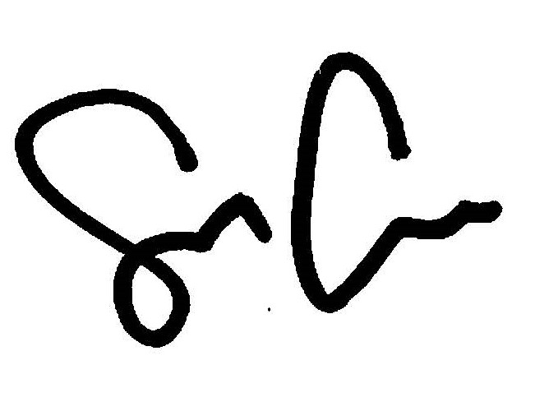
By: ___________________________________
Shaun Callahan/ARDC#6296022
Attorney, Marinosci Law Group, P.C.
Firm No.: 59049

MARINOSCI LAW GROUP, P.C.
134 N. LaSalle Street, Suite 1900
Chicago, IL 60602
Telephone: 312-940-8580
Fax: 401-234-5130
Firm No.: 59049
mlgil@mlg-defaultlaw.com

SERVICE LIST

LAW OFFICES OF IRA T. NEVEL, LLC
Via electronic mail to: pleadings@nevellaw.com

